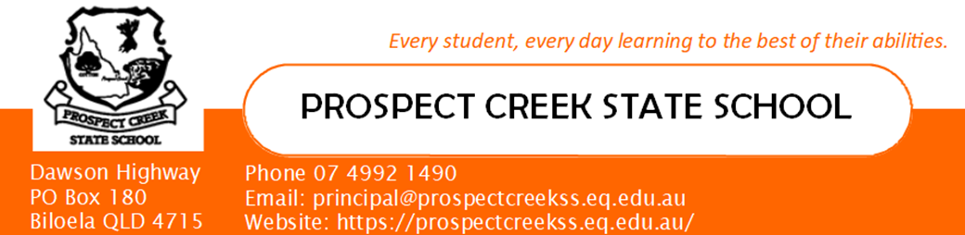

Student Booklist 2024: Prep

Dear Parents,  The list of textbooks your child will use in 2024, and the stationery that you child will require is listed here. Please ensure all items are named and ready to use the first day next year. Excess supplies also need to be sent into the school and will be stored in a name bag in a teacher access only supply cupboard. These will be given to the student as they require them with unused items returned at the end of the year.  Regards,  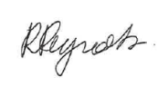  Miss Rosalie Reynolds  Principal | These items are to be supplied by the parent for the first day of school: 22nd January 2024. Please label all items and if you already have any of the supplies it is not necessary to buy new ones.  STATIONERY  Wooden ruler – 30cm with cm/mm no inches 1  Scissors 1  Large glue stick (2 per term) 8  Junior Triangular HB pencils 2 Boxes  Staedtler Compact Whiteboard Markers 2 packets  Red pen 1  White rectangular erasers 6  Metal Sharpener with shaving container 1  Coloured pencils or Twister retractable crayons 1 pack  Felt pens 1 pack  Highlighters: must include orange, blue, green, pink 1 pack  Blank scrapbooks 2  A4 Botany exercise books 2  A4 Magic Storybook A4 Page 1/3 Plan; 2/3 12mm Olympic brand 2  A4 Year 1 lined book, red and blue lined 2  A4 quad books – larger squares 1  Box of tissues 1  Ream of A4 white paper 1  Prep Targeting QLD Handwriting Book 1  A5 Student Diary 1  Only if students do not currently have  Large Pencil Case 1  Library Bag 1  Clip board 1  Headset volume control verbatim USB input (good but not too expensive) 1  Homework and home readers folder 2

